

40

Target: ___/15 or ____ % 👍 👎

Year 8 HASS- Civics and Citizenship

***Task 3: In Class Short Answer Response (7.5%)***

Part A: Multiple Choice Questions

Circle the correct answer to the following questions. (1 mark each; 10 marks total)

**1 Which of the following would be considered Civil Law:**

**A** Murder

**B** Assault

**C** Arson

**D** Divorce

**2 Which of the following is NOT a Law in Australia:**

**A** Stopping at a red light.

**B** Calling 000 in situations where it is not an emergency.

**C** Chewing gum.

**D** You have to be 18 to vote in elections

**3 Which of the following is a common consequence for breaking a rule:**

**A** Detention.

**B** Jail.

**C** Fines.

**D** Criminal Record.

**4** **Which of the following best describes the term ‘deterrent’:**

**A** Something that encourages someone to do something.

**B** Something that increases the cost of items

**C** Something that helps you learn Spanish.

**D** Something that discourages someone from doing something.

**5 A barking dog would be considered which type of ‘Tort Law’:**

**A** Trespass.

**B** Negligence.

**C** Defamation.

**D** Nuisance.

**6 Types of Laws in Australia include:**

**A** Rules, Statutes, Criminal and Civil.

**B** Common, Criminal, Civil and Statute.

**C** Common, Civil, Uncivil and Criminal.

**D** Common, Rules, Civil and Uncommon.

**7 Which of the following best defines Rules:**

**A** A set of explicit guidelines or principles governing an activity.

**B** A set of regulations that is enforced by the Government and applies to all Citizens.

**C** An individual having absolute power, without limitations, over others.

**D** A system of organisation where the members are given power.

**8 Which of the following best defines Laws:**

**A** A set of explicit guidelines or principles governing an activity.

**B** A set of regulations that is enforced by the Government and applies to all Citizens.

**C** An individual having absolute power, without limitations, over others.

**D** A system of organisation where the members are given power.

**9 A Statutory Law is produced in:**

**A** Parliament.

**B** Kirribilli House

**C** Buckingham Palace.

**D** Courts.

**10 Common Law is produced in:**

**A** Parliament.

**B** Kirribilli House

**C** Buckingham Palace.

**D** Courts.

Part B: Short-answer questions (7 Questions, 30 marks)

1. **List** the three main types of Civil Law

*(3 marks)*

* *________________________________*
* ________________________________
* ________________________________

1. **Define** Statutory Law and provide an example to support your response. *(3 marks)*

__________________________________________________________________________________________________________________________________________________________________________________________________________________________________________

1. **Define** Common Law and provide an example to support your response. *(3 marks)*

__________________________________________________________________________________________________________________________________________________________________________________________________________________________________________

1. 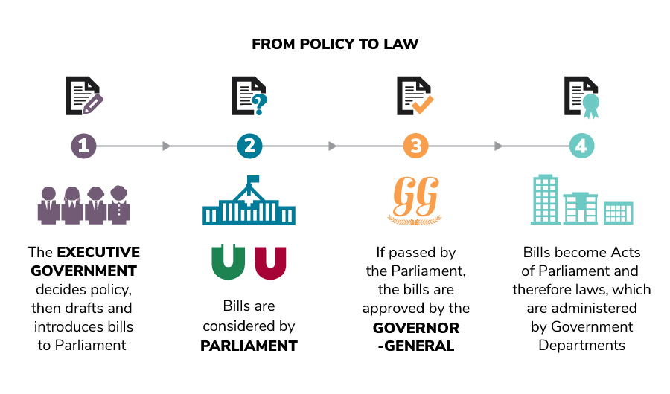**Identify** the four missing components for the path of a Bill ‘From Policy to Law’ in Australia (4 marks).

If the bills are passed, then they are approved and given Royal Assent by this individual.

The Bill is officially approved a law at this stage and is administered by Government Departments.

Within this branch of Government, the two houses consider the Bills.

This branch of Government decides policy, then drafts and introduces bills to Parliament

1. **Explain** how a Bill is passed in Australia and it becomes an Act of Parliament. (7 marks)

(Remember to include the name and role of the houses, the path the bill travels, the function of each reading, and the final steps before it becomes a law).

__________________________________________________________________________________________________________________________________________________________________________________________________________________________________________________________________________________________________________________________________________________________________________________________________________________________________________________________________________________________________________________________________________________________________________________________________________________________________________________________________________________________________________________________________________________________________________________________________________________________________________________________________________________________

1. Compare and contrast the difference between Civil and Criminal Laws, using an example for each to support your response (5 marks)

_____________________________________________________________________________________________________________________________________________________________________________________________________________________________________________________________________________________________________________________________________________________________________________________________________________________________________________________________________________________________________________________________________________

1. Using your knowledge of the different types of laws, label the scenarios contained in the table below as either *civil* or *criminal. (5 marks)*

|  |  |
| --- | --- |
| **Scenario** | **Type of Law**  *Civil or Criminal* |
| A 22 year old man is using his mobile phone to text a friend and is driving too fast (but not above the speed limit) as he approaches a roundabout. A bike rider goes through the roundabout very quickly in front of him and he clips the back wheel of her bike with his car. The bike rider is killed. |  |
| A security guard (the plaintiff) was injured at work when she was punched by a patron outside a party. She injured her neck and back and needs surgery. She does not recover from her injuries and becomes depressed. |  |
| Elaine, a 35-year old teacher, got a ticket for driving 75 miles per hour in a 35 mile per hour zone. |  |
| Jane, 25 years old, was caught stealing $150 worth of candies from a nearby department store. She had been apprehended by the police twice before. |  |
| Jan was invited to dinner at Richard’s apartment. Richard had just completed mopping the apartment and the floor was still very wet. Jan took two steps into the apartment, fell on her side and broke a finger |  |

**END OF PART B**

**END OF ASSESSMENT**